Name : Alveena naz
Reg No. FA25-BSE-010
PF Assignment 3

Question 1:
import java.util.Scanner;
import java.util.Arrays;
public class Shape
{
public static void main(String[] args)
{
Scanner input = new Scanner(System.in);
int arr[]=new int[10];
int arr1[]=new int[arr.length];

for(int i=0;i<arr.length;i++)
{
arr[i]=input.nextInt();
}
// Check for distinctive numbers
int count =0;
for(int i=0;i<arr.length;i++)
{
boolean found = false;
for(int j =0;j<count;j++)
{
if(arr[i]==arr[j])
found = true;
break;
}
if(found==false)
{
arr1[count]=arr[i];
count++;
}
}

//Print arryay

for(int i =0;i<arr1.length;i++)
{
System.out.print(arr1[i] + " ");
}
}// close of main method
}
OUTPUT:
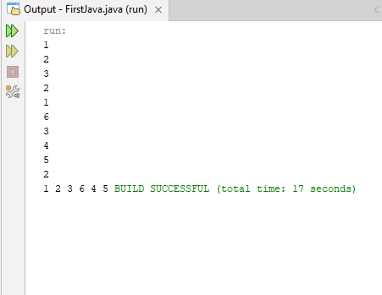

Question 2:
import java.util.Scanner;
import java.util.Arrays;
public class Shape
{
static int count =0;
public static void main(String[] args)
{
Scanner input = new Scanner(System.in);
int arr[]=new int[10];
int arr1[]=new int[arr.length];

for(int i=0;i<arr.length;i++)
{
arr[i]=input.nextInt();
}
eliminateDuplicates(arr,arr1);

//Print arryay
System.out.println(" The array without duplicat value is ");
for(int i =0;i<count;i++)
{
System.out.print(arr1[i] + " ");
}
}//Closing of main method
static int[] eliminateDuplicates(int[] arr,int[] arr1)
{

for(int i=0;i<arr.length;i++)
{
boolean found = false;
for(int j =0;j<count;j++)
{
if(arr[i]==arr[j])
{
found = true;
break;
}
}
if(found==false)
{
arr1[count]=arr[i];
count++;
}
}
return arr1;
}
} // close of class

Question 3:
import java.util.Scanner;
import java.util.ArrayList;
import java.util.Collections;
public class Shape
{
static int count =0;
public static void main(String[] args)
{
Scanner input = new Scanner(System.in);
ArrayList<Integer>arr=new ArrayList<>();
System.out.println(" Enter values of Array List and 0 to stop entering");
while(true)
{
int n = input.nextInt();
if(n==0)
break;

arr.add(n);
}
boolean check = isSorted(arr);
if(check==true)
{
System.out.println(" The list is already sorted");
}
Else
{
Collections.sort(arr);

//print List
System.out.println(" The sorted List is ");
for(int i =0;i<arr.size();i++)
{
System.out.print(arr.get(i)+ " ");
}
}
}
static boolean isSorted(ArrayList<Integer>arr)
{
for(int i=0;i<arr.size()-1;i++)
{
if(arr.get(i)>arr.get(i+1))
return false;
}
return true;
}
}

OUTPUT:
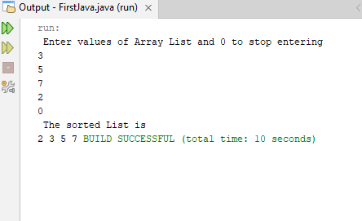
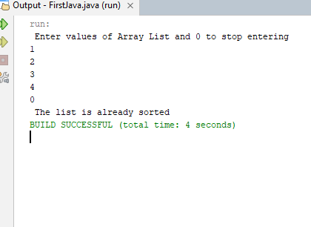

Question 4:
import java.util.Scanner;
import java.util.ArrayList;
import java.util.Collections;
public class Shape
{
public static void main(String[] args)
{
Scanner input = new Scanner(System.in);
System.out.println(" Enter the number of values");
int n = input.nextInt();
int arr[]=new int[n];
for(int i =0;i<n;i++)
{
arr[i]=input.nextInt();
}

boolean check=isConsecutiveFour(arr);
if(check==true)
System.out.println(" The array has consecutive fours");
else
System.out.println(" The array has no consecutive fours");

}
static boolean isConsecutiveFour(int[] arr)
{
int count =1;
for(int i=1;i<arr.length;i++)
{
if(arr[i]==arr[i-1])
{
count++;
if(count==4)
{
return true;
}
}
else
{
count =1;
}
}
return false;
}
}

OUTPUT:
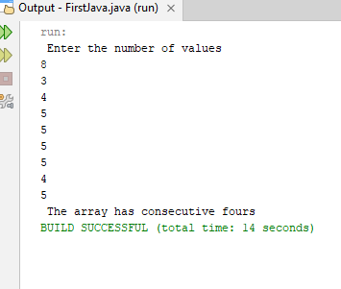
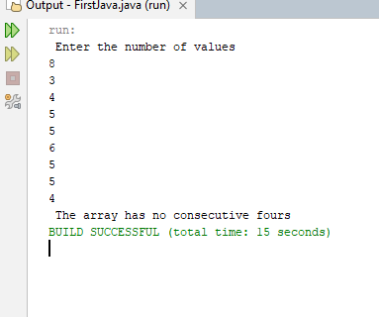

Question 5:
import java.util.Scanner;
import java.util.Arrays;
import java.util.Collections;
public class Shape
{
public static void main(String[] args)
{
Scanner input = new Scanner(System.in);
System.out.println(" Enter the number of values in first array");
int n1 = input.nextInt();
int arr1[]=new int[n1];
for(int i =0;i<n1;i++)
{
arr1[i]=input.nextInt();
}
System.out.println(" Enter the number of values in Second array");
int n2 = input.nextInt();
int arr2[]=new int[n2];
for(int i =0;i<n2;i++)
{
arr2[i]=input.nextInt();
}
int merge[]= new int[n1+n2];
// Copy first array
for(int i =0;i<n1;i++)
{
merge[i]=arr1[i];
}
//copy second array
for(int i =0;i<n2;i++)
{
merge[arr1.length+i]=arr2[i];
}

Arrays.sort(merge);
//print merge sorted array
System.out.println(" The merged Sorted Array is ");
for(int i =0;i<merge.length;i++)
{
System.out.print(merge[i]+ " ");
}

}
}

OUTPUT:
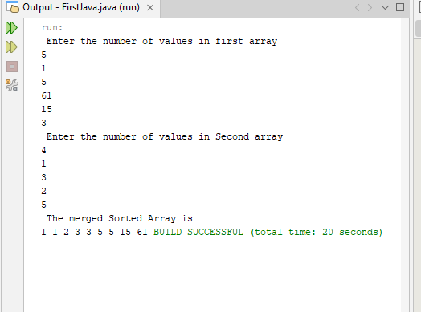

Question 6:
import java.util.Scanner;
import java.util.Arrays;
import java.util.Collections;
public class Shape
{
public static void main(String[] args)
{
Scanner input = new Scanner(System.in);
System.out.println(" Enter the number of rows in first matrix");
int r1 = input.nextInt();
System.out.println(" Enter the number of coloumns in first matrix");
int c1 = input.nextInt();
int arr1[][]=new int[r1][c1];
System.out.println(" Enter values of first matrix");
for(int i =0;i<r1;i++)
{
for(int j =0;j<c1;j++)
{
arr1[i][j]=input.nextInt();
}
}
System.out.println(" Enter the number of rows in Second matrix");
int r2 = input.nextInt();
System.out.println(" Enter the number of coloumns in second matrix");
int c2 = input.nextInt();
System.out.println(" Enter values of second matrix");
int arr2[][]=new int[r2][c2];
for(int i =0;i<r2;i++)
{
for(int j =0;j<c2;j++)
{
arr2[i][j]=input.nextInt();
}
}
// array to store product of two matrix
int product[][]=new int[r1][c2];

//Check for order
if(c1!=r2)
{
System.out.println(" Multiplication is not possible");
return;
}

for(int i =0;i<r1;i++)
{
for(int j =0;j<c2;j++)
{
product[i][j]=0;
for(int k=0;k<c1;k++)
{
product[i][j]+=arr1[i][k]*arr2[k][j];
}
}
}// closing of outer loop

//print product array
for(int i =0;i<product.length;i++)
{
for(int j =0;j<product[i].length;j++)
{
System.out.print(product[i][j]+ " ");
}
System.out.println();
}

}
}

OUTPUT:
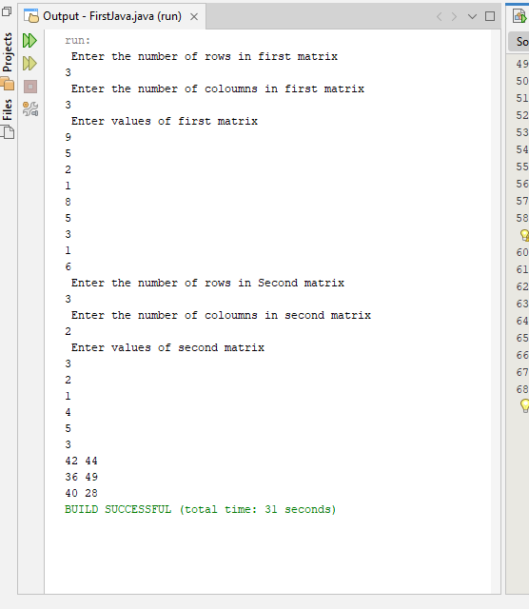

Question 10:
import java.util.Scanner;
import java.util.Arrays;
import java.util.Collections;
public class Shape
{
public static void main(String[] args)
{
Scanner input = new Scanner(System.in);
System.out.println(" Enter the number of rows in first matrix");
int r1 = input.nextInt();
System.out.println(" Enter the number of coloumns in first matrix");
int c1 = input.nextInt();
int arr1[][]=new int[r1][c1];
System.out.println(" Enter values of first matrix");
for(int i =0;i<r1;i++)
{
for(int j =0;j<c1;j++)
{
arr1[i][j]=input.nextInt();
}
}
System.out.println(" Enter the number of rows in Second matrix");
int r2 = input.nextInt();
System.out.println(" Enter the number of coloumns in second matrix");
int c2 = input.nextInt();
System.out.println(" Enter values of second matrix");
int arr2[][]=new int[r2][c2];
for(int i =0;i<r2;i++)
{
for(int j =0;j<c2;j++)
{
arr2[i][j]=input.nextInt();
}
}
// array to store product of two matrix
int product[][]=new int[r1][c2];

//Check for order
if(c1!=r2)
{
System.out.println(" Multiplication is not possible");
return;
}

for(int i =0;i<r1;i++)
{
for(int j =0;j<c2;j++)
{
product[i][j]=0;
for(int k=0;k<c1;k++)
{
product[i][j]+=arr1[i][k]*arr2[k][j];
}
}
}// closing of outer loop

//print product array
for(int i =0;i<product.length;i++)
{
for(int j =0;j<product[i].length;j++)
{
System.out.print(product[i][j]+ " ");
}
System.out.println();
}

}
}

Question 7:
import java.util.Scanner;
import java.util.Arrays;
import java.security.SecureRandom;
public class Shape
{
public static void main(String[] args)
{
Scanner input = new Scanner(System.in);
System.out.println(" Enter the length of a square matrix");
int n = input.nextInt();
int square[][]=new int[n][n];
SecureRandom random = new SecureRandom();
for(int i=0;i<n;i++)
{
for(int j=0;j<n;j++)
{
square[i][j]=random.nextInt(2);
}
}

//print this array
for(int i=0;i<n;i++)
{
for(int j=0;j<n;j++)
{
System.out.print(square[i][j]+" ");
}
System.out.println();
}

//Check for rows
boolean rowFound = false;
for(int i=0;i<n;i++)
{
boolean allZero = true;
boolean allOnes = true;
for(int j =0;j<n;j++)
{
if(square[i][j]!=0)
{
allZero=false;
}
if(square[i][j]!=1)
{
allOnes=false;
}

}
if(allZero)
{
System.out.println(" all 0s on row " + i);
rowFound = true;
}
else if(allOnes)
{
System.out.println(" All 1s on row " + i);
rowFound = true;
}

}
if(!rowFound)
System.out.println(" No same numbers on rows");
//Check for colomns

boolean colFound = false;
for(int i=0;i<n;i++)
{
boolean allZero = true;
boolean allOnes = true;
for(int j =0;j<n;j++)
{
if(square[j][i]!=0)
{
allZero=false;
}
if(square[j][i]!=1)
{
allOnes=false;
}

}
if(allZero)
{
System.out.println(" all 0s on column " + i);
colFound = true;
}
else if(allOnes)
{
System.out.println(" All 1s on column" + i);
colFound = true;
}

}
if(!colFound)
System.out.println(" No same numbers on columns");

//Check for major diagnol
boolean allZero = true;
boolean allOnes = true;
for(int i=0;i<n;i++)
{
if(square[i][i]!=0)
allZero = false;
if(square[i][i]!=1)
allOnes = false;

}
if(allZero)
{
System.out.println(" all 0s on found on major diagnal");

}
else if(allOnes)
{
System.out.println(" All 1s on Major Diagnal");

}
else
{
System.out.println(" No same numbers on major Diagnol");
}
//Check for subDiagnol
allZero = true;
allOnes = true;
for(int i=0;i<n;i++)
{
for(int j = n-1;j>=0;j--)
{
if(square[i][j]!=0)
allZero = false;
if(square[i][j]!=1)
allOnes = false;
}

}
if(allZero)
{
System.out.println(" all 0s on found on Subdiagnal");

}
else if(allOnes)
{
System.out.println(" All 1s on Subdiagnal");

}
else
{
System.out.println(" No same numbers on subdiagnol");
}

}
}

OUTPUT:
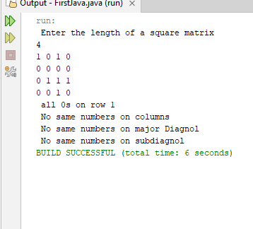

Question 8:
import java.util.Scanner;
import java.util.Arrays;
import java.security.SecureRandom;
public class Shape
{
public static void main(String[] args)
{
Scanner input = new Scanner(System.in);
int student[][]=new int[10][6];
for(int i =0;i<10;i++)
{
System.out.println(" Enter the roll no. of " + (i+1) +" student");
student[i][0]=input.nextInt();
System.out.println("Enter marks of 5 Subjects");

for(int j =1;j<6;j++)
{
student[i][j]=input.nextInt();
}
}

//Check For highest total Marks
int maxTotal =0;
int rollMaxTotal =0;
for(int i=0;i<10;i++)
{
for(int j =1;j<6;j++)
{
if(student[i][j]>maxTotal)
{
maxTotal = student[i][j];
rollMaxTotal = student[i][0];
}
}
}
System.out.println(" Student with the highest total marks: Roll no. = " + rollMaxTotal);
//Check if there is same highest marks of student
for(int i=0;i<10;i++)
{
if(student[i][1]==maxTotal)
{
System.out.println(" Roll No: " + student[i][0]);
}
}
//Highest PF marks
int maxPf =0;
int rollMaxPf=0;
for(int i=0;i<10;i++)
{
if(student[i][1]>maxPf)
{
maxPf=student[i][1];
rollMaxPf=student[i][0];
}
}
System.out.println(" Student with the highest PF marks: Roll no. = " + rollMaxPf);
//Check if there is same PF marks
for(int i=0;i<10;i++)
{
if(student[i][1]==maxPf)
{
System.out.println(" Roll No: " + student[i][0]);
}
}
//Each student highest marks

for(int i=0;i<10;i++)
{
int highest =0;
int rollHighest =0;
for(int j =1;j<6;j++)
{
if(student[i][j]>highest)
{
highest = student[i][j];
rollHighest = student[i][0];
}
}
System.out.println("Roll no. " + rollHighest + " : Highest Marks " + highest);
}

}
}

OUTPUT:
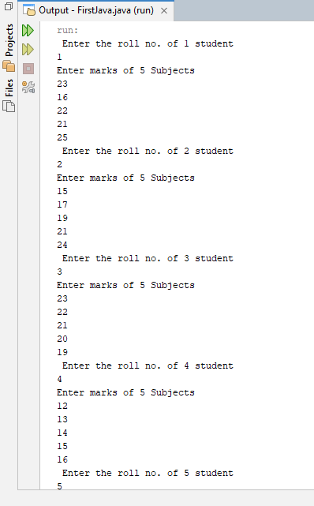
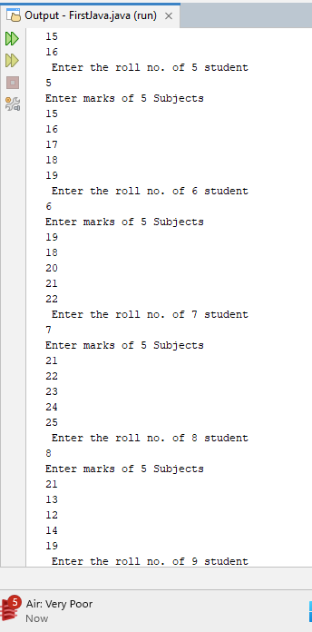
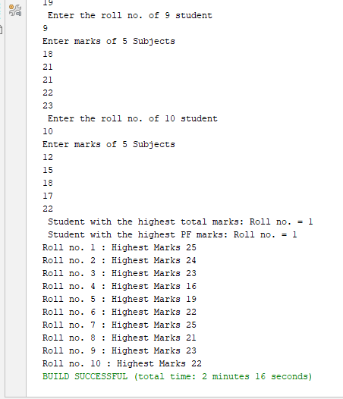

Question 9:

